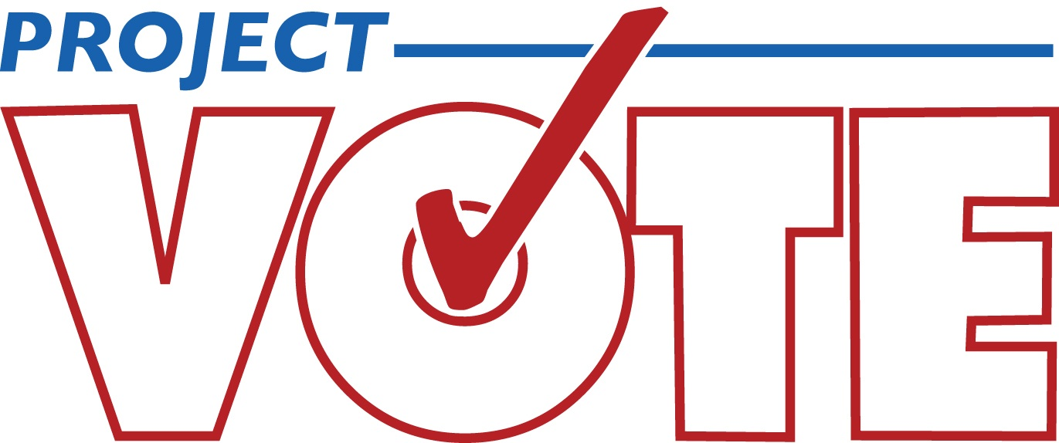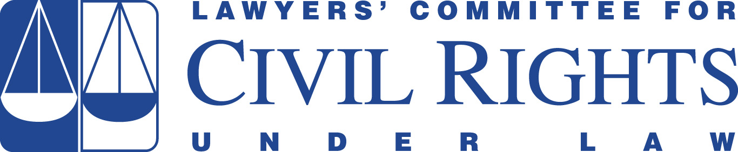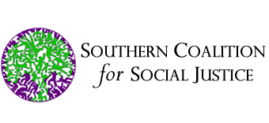

May 8, 2015

Via certified mail and email

Kim Westbrook Strach
Executive Director, North Carolina State Board of Elections
PO Box 27255
Raleigh, NC 27611-7255
kim.strach@ncsbe.gov

RE: Compliance with Section 7 of the National Voter Registration Act

Dear Ms. Strach:

We write on behalf of Action NC, Democracy North Carolina, the A. Philip Randolph Institute, persons eligible to register to vote that these organizations represent, and others similarly situated to notify you that the State of North Carolina is not in compliance with Section 7 of the National Voter Registration Act of 1993 (“NVRA”), 52 U.S.C. § 20506, which requires States, including North Carolina, to provide individuals with a meaningful opportunity to register to vote when interacting with public assistance agencies.

In the past, North Carolina has been responsive when notified of the State’s failure to comply with provisions of the NVRA. Less than 10 years ago, Dēmos, Project Vote, and Lawyers’ Committee for Civil Rights Under Law approached the North Carolina State Board of Elections (“NCSBE”) after observing that State practices were failing to meet the standards set in Section 7 of the NVRA. We were able to work successfully with the NCSBE to, within two months, develop a comprehensive compliance plan for North Carolina. This plan succeeded in increasing the number of individuals registering through public assistance agencies six-fold, and we held it out as a model to be followed by other states.

In recent years, North Carolina’s compliance with the NVRA has, once again, begun to decline. We hope that we may reestablish our strong working relationship with the NCSBE to help ensure that North Carolina’s public assistance agencies are meeting their Section 7 obligations. And, we urge you, as the State’s chief election official, to take immediate steps, in conjunction with the Department of Health and Human Services (“DHHS”), to bring the State into compliance with federal law.

- The Requirements of the National Voter Registration Act of 1993

Section 7 of the NVRA requires North Carolina to “designate as voter registration agencies . . . all offices in the State that provide public assistance.” See 52 U.S.C. § 20506(a)(2)(A). “Public assistance” programs that must provide voter-registration services under Section 7 include, at a minimum, the Supplemental Nutrition Assistance Program (“SNAP”), Temporary Assistance for Needy Families (“TANF”), the Special Supplemental Nutrition Program for Women, Infants and Children (“WIC”), the Medicaid program, and the Children’s Health Insurance Program (“CHIP”). See, e.g., U.S. Department of Justice, The National Voter Registration Act of 1993 (NVRA): Questions and Answers, Q13, http://www.justice.gov/ crt/about/vot/nvra/nvra_faq.php (last visited May 8, 2015). In North Carolina, these programs are administered by DHHS.

The NVRA mandates that public assistance offices provide voter registration opportunities whenever an individual is engaging in a “covered transaction” (an application, renewal, recertification, or change of address transaction). In order to fulfill their voter registration obligations, each public assistance office must (i) distribute voter registration application forms; (ii) assist applicants in completing the voter registration forms, unless such assistance is refused by the applicant; and (iii) accept completed voter registration application forms and forward them to the appropriate election official. See 52 U.S.C. § 20506(a)(4)(A). Moreover, each office must (i) inquire of the applicant, in writing, whether he or she would like to register to vote or change his or her voter registration address; (ii) distribute a voter registration application form with each covered transaction, unless the individual applicant or client affirmatively opts out of voter registration by declining in writing to register to vote; (iii) inform the applicant, in writing, that the decision to register or decline to register to vote will not affect the amount of public assistance provided by the agency; and (iv) provide assistance in completing the voter registration forms to the same degree the agency provides assistance in completing its own forms. See 52 U.S.C. § 20506(a)(6).

These voter registration services must be provided by public agencies, regardless of whether a covered transaction takes place in person at an agency office or remotely via phone, mail, email, or internet. Georgia Conf. of the NAACP v. Kemp, 841 F. Supp. 2d 1320, 1331 (N.D. Ga. 2012) (voter registration must be provided during remote transactions); see also U.S. Department of Justice, The National Voter Registration Act of 1993 (NVRA): Questions and Answers, Q24. Moreover, it is worth emphasizing that each client engaging in a covered transaction must receive a voter registration application unless he or she declines in writing. See Valdez v. Squier, 676 F.3d 935, 945-46 (10th Cir. 2012) (The NVRA “must be interpreted as requiring a designated voter registration agency to provide an applicant with a voter registration form unless the applicant declines, in written form, to register to vote. . . . Thus, in sum, [the NVRA] requires an applicant to affirmatively, by way of writing, ‘opt out’ of receiving a voter registration form.”). Thus, someone who fails to provide a response to the mandatory voter registration question must receive a voter registration application.

As discussed below, North Carolina’s public assistance agencies are failing to fulfill their NVRA obligations.

- North Carolina’s Non-Compliance with the NVRA

North Carolina’s violations of Section 7 of the NVRA are demonstrated by multiple sources of information, including data reported by the NCSBE as well as the state Department of Health and Human Services, DHHS program forms, interviews conducted at North Carolina Department of Social Services (“DSS”) and Public Health (“WIC”) offices (collectively “DHHS offices”); and review of third-party contractor processes. Together, the sources of information reveal that DHHS is systematically failing to provide the voter registration services mandated by Section 7 the NVRA.

As described in greater detail below, the results of our investigation indicate that DHHS is engaged in continuing violations of the NVRA. At a minimum, DHHS is violating its obligation to provide the voter preference form and to distribute voter registration applications to clients engaged in covered transactions occurring in person or through remote means. Because it is not providing applications, DHHS is obviously not offering the required assistance in completing them. We expect that further review, conducted in the context of litigation or otherwise, will reveal additional continuing NVRA violations.

- Voter Registration Data

Data from the NCSBE shows that—after many years of stability punctuated by spikes around presidential elections—the number of voter registration applications originating from North Carolina public assistance agencies has decreased dramatically in the last two reported years.

Year | 2007 | 2008 | 2009 | 2010 | 2011 | 2012 | 2013 | 2014
Number of Applications Submitted by Public Assistance Agencies | 33,101 | 42,672 | 33,705 | 36,824 | 42,988 | 41,162 | 18,758 | 13,340
* Information in this table is from the North Carolina State Board of Elections, available at ftp://alt.ncsbe.gov/NVRA/NVRA%20Reports/PublicAssistanceActivity2008-14.xlsx; ftp://alt.ncsbe.gov/NVRA/ NVRA%20Reports/.

From 2011, the year of peak registrations, to 2014, the number of applications dropped by nearly 69%, from 42,988 to 13,340.

These reductions cannot be explained by a corresponding decline in the caseload at DHHS. For example, the number of applications for public assistance services submitted to DHHS dropped by approximately 22.5 percent between 2011 and 2013, while the decline in DHHS-generated voter registration applications fell by more than 56 percent over the same period. Thus, while DHHS’s caseload has diminished, the decrease represents only a fraction of the reduction in voter registration applications.

b. Field Investigations at DHHS Offices

During October 2014, field investigators visited 19 DHHS offices in 11 North Carolina counties. Field observations confirm that frontline staff at DHHS offices consistently fail to distribute voter registration applications to public assistance clients, as required by the NVRA.

While workers at some public assistance offices described NVRA-compliant procedures, their factual assertions were not supported by interviews conducted with clients exiting the offices. For example, interviews conducted with 196 DHHS clients – who reported that they were eligible to vote and had engaged in a covered transaction – revealed:

- Three-quarters of interviewees received no offer of voter registration of any kind. Specifically, 146 clients (74.5%) did not see a voter registration question on their forms, were not verbally asked whether they would like to receive a voter registration application, and did not receive a voter registration application.

- At offices that claimed to distribute voter registration applications to everyone, 74% of interviewees stated that they had neither (i) received an application, nor (ii) declined the opportunity to register to vote, either verbally or in writing.

- At the four offices that claimed to ask each client whether s/he would like a voter registration application, 92% of the interviewees stated that they had not seen or responded to a voter registration question on their forms, and 93% of interviewees stated that no one had verbally offered them a registration application.

While it is possible that a voter registration question appears on at least some DHHS forms used during covered transactions, individuals who did not see any voter registration question would have failed to respond to any “missed” question. As explained above, each such individual should have received a voter registration application, as the NVRA mandates that each client engaging in a covered transaction must receive a voter registration application unless he or she declines in writing. The high number of individuals who reported they did not see a voter registration question, did not respond to a voter registration question, and did not receive a voter registration application demonstrates that DHHS is routinely disregarding the provisions set forth in the NVRA.

Significantly, six of the 19 offices (31.6%) lacked even the materials, procedures, and/or infrastructure to comply with the NVRA:

- Four offices did not have voter registration applications onsite;

- One office failed to collect any voter registration applications; and

- One office provided voter registration applications to clients only upon request.

c. Third-Party Contractors

DHHS provides millions of dollars in funding to nonprofit, community-based organizations that distribute food and grocery products to eligible individuals in North Carolina. Among other responsibilities, DHHS has delegated to these grantees the responsibility to enroll individuals in the SNAP program.

It is our understanding that these third-party contractors do not perform the required NVRA voter registration services when engaging in covered transactions (because DHHS has not directed or equipped them to do so). Regardless of whether a public assistance transaction is conducted by DHHS or by a nongovernmental entity with which the state agency has contracted, the NVRA requires North Carolina and DHHS to provide voter registration with each covered transaction. See Department of Justice, The National Voter Registration Act of 1993 (NVRA): Questions and Answers, Q5 (“When a state contracts with a private entity to administer services in an agency that is required to offer voter registration, the ultimate responsibility for ensuring provision of voter registration services remains with the state, and the voter registration requirements under the NVRA remain the same.”).

- Conclusion

This letter, pursuant to 52 U.S.C. § 20510(b), serves as notice of NVRA violations by DHHS, as an agency offering public assistance benefits.

Publicly available data and other information demonstrate that DHHS is engaged in ongoing violations of the NVRA. The Executive Director of the State Board of Elections and the Secretary of DHHS are responsible for ensuring NVRA compliance by DHHS, including by local DHHS offices and third-party contractors. See N.C. G.S. § 163-82.2; see also Harkless v. Brunner, 545 F.3d 445, 451 (6th Cir. 2008) (chief election official is “responsible for implementing the state’s function”); id. at 455 (head of “single state agency” responsible for administering public assistance programs has responsibility to provide statewide voter registration services).

North Carolina must make prompt changes to ensure that the NVRA is properly implemented so that all of its citizens, including the more than one million individuals who receive public assistance, are able to register to vote and participate in elections.

We would be pleased to work cooperatively with the NCSBE and DHHS to develop a plan for bringing North Carolina into compliance with the NVRA, as we have successfully done with North Carolina previously as well as with other states. We are prepared to meet with you and other state officials, at your earliest convenience, to assist in your development of a comprehensive compliance plan. In the absence of such a plan, we will have no alternative but to initiate litigation at the conclusion of the statutory 90-day waiting period.

Please advise us promptly of the steps you intend to take to remedy North Carolina’s violations of Section 7 of the NVRA.

Sincerely,

___Stuart Naifeh________
Stuart Naifeh
Naila Awan
Dēmos
220 Fifth Ave,. 2nd Floor
New York, NY, 10001
(212) 633-1405

___Robert A. Kengle________
Robert A. Kengle
Lawyers’ Committee for Civil Rights Under Law
1401 New York Avenue, NW, Suite 400
Washington, D.C. 20005

_Catherine M. Flanagan_____
Catherine M. Flanagan
Sarah Brannon
Project Vote
1350 I Street NW, Suite 1250
Washington, DC 20005
(202) 546-4173

___Allison Riggs____________
Allison Riggs
Anita Earls
Southern Coalition for Social Justice
1415 West Highway 54, Suite 101
Durham, NC 27707

cc: Dr. Aldona Wos
Secretary
North Carolina Department of Health and Human Service
2001 Mail Service Center
Raleigh, NC 27699-2001
Aldona.wos@dhhs.nc.gov

See, e.g., Dēmos, Expanding Voter Registration for Low-Income Citizens: How North Carolina is Realizing the Promise of the National Voter Registration Act, April 2008, available at http://www.demos.org/sites/default/files/publications/NVRA_North_Carolina_Demos.pdf.
The NVRA provides specific language that must be used to make this inquiry, known as the Voter Preference Question. The NVRA mandates that individuals engaging in covered transactions with public assistance offices must be provided a form that asks: “If you are not registered to vote where you live now, would you like to apply to register to vote here today?” See 52 U.S.C. § 20506(a)(6)(B)(i).
See Valdez v. Squier, 676 F.3d 935, 945-46 (10th Cir. 2012) (noting that, during covered transactions, public assistance agencies must provide a voter registration form to any client who does not decline to register to vote in writing).
This statement is one of several statutory disclosures required by Section 7. See 52 U.S.C. § 20506(a)(6)(B)(iv) and (v).
The most recent Election Assistance Commission (“EAC”) NVRA Report was released in 2013 and addressed data is from 2011-2012. We expect the 2013 and 2014 data to be reflected in the 2013-2014 EAC NVRA Report.
The Medicaid application provided on DHHS’ website provides an additional indicia of noncompliance. The application does not contain the Voter Preference Question and checkboxes mandated by Section 7. See 52 U.S.C. § 20506(a)(6)(B)(i) and (iii). Neither does it contain the required disclosures. See 52 U.S.C. § 20506(a)(6)(B). Additionally, it instructs applicants who wish to register to vote to complete the voter registration form found at the Board of Elections website. See Medicaid Application, DMA-5200, p. 12, available at http://info.dhhs.state.nc.us/olm/forms/ dma/dma-5200-ia.pdf. Merely providing a link to a voter registration application that must be printed out by applicants fails to comply with the Section 7’s voter registration application distribution requirements. See Ferrand v. Schedler, No. 2:11-cv-00926-JTM-JCW, 2013 WL 264603, at *25-26 (E.D. La. 2013) (holding that merely providing a link to a downloadable voter registration application during public assistance application process did not comply with the NVRA) vacated on standing grounds, Scott v. Schedler, 771 F.3d 831 (5th Cir. 2014); see also 52 U.S.C. § 20506(a)(6)(A). In order to be NVRA-compliant, DHHS must offer to mail clients a voter registration application to effect distribution to those who lack access to a computer and printer.
See Letter to Joint Legislative Oversight Committee on Health and Human Services from Adam Sholar, Director of Government Affairs, DHHS, June 27, 2014, available at http://www.ncleg.net/documentsites/committees/JLOCHHS/Handouts%20and%20Minutes%20by%20Interim/2014-15%20Interim%20HHS%20Handouts/September%209,%202014/Reports/ DHHS%20Nonprofit%20Grants%20Report%2062714.pdf.

